Raspberry Pi – Webcam Server Project

Objective: Using the pi camera, turn the Raspberry Pi into a web camera server.

# Step 1: Configure the Raspberry Pi camera

After connecting the camera to the raspberry pi board, you have to enable it. In order to do this, you can either go to preferences and open the raspberry pi configuration, or in command prompt, enter the command: “sudo raspi-config”. This opens up the window shown below, where you can select interfacing options. Then go to camera, and select enable camera; exit without updating

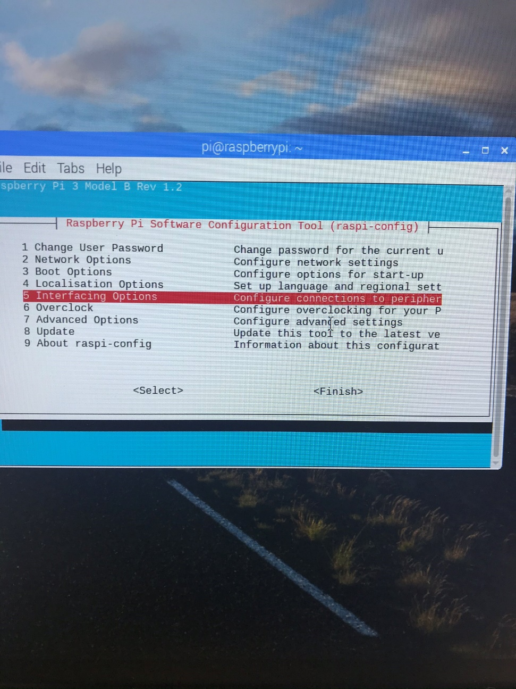

# Step 2: Install rpi-update and run it

In cmd, use “sudo apt-get install rpi-update” to install it, and then “sudor pi-update” run the updater. Once it is done, reboot the raspberry pi.

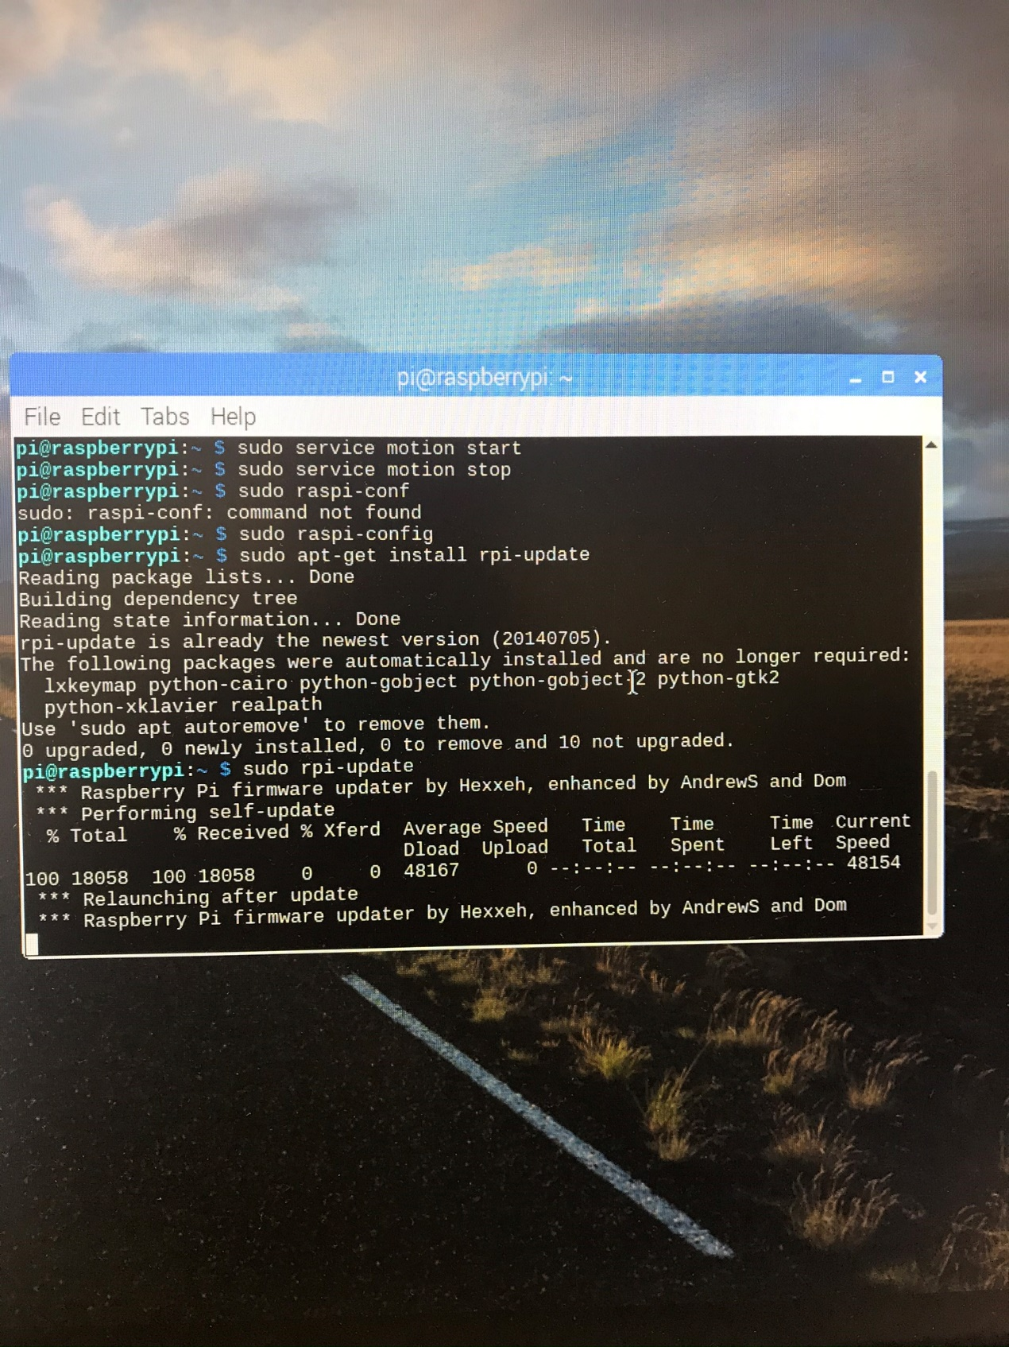

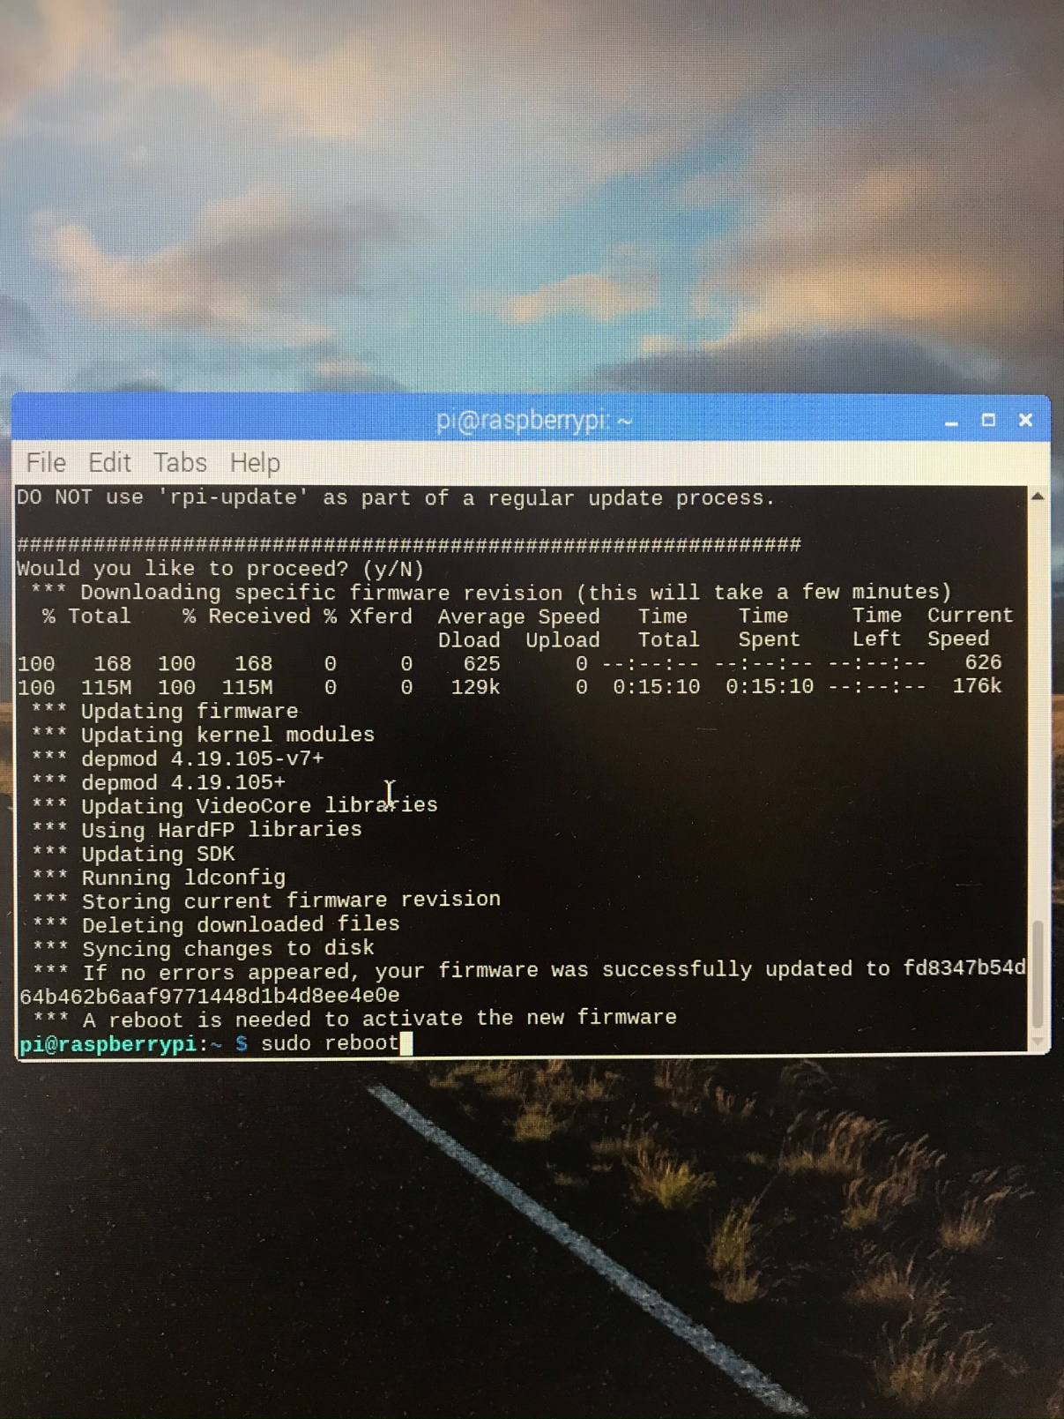

# Step 3: Install libjpeg62

Again, use the “sudo apt-get install” command in cmd, to install libjpeg62

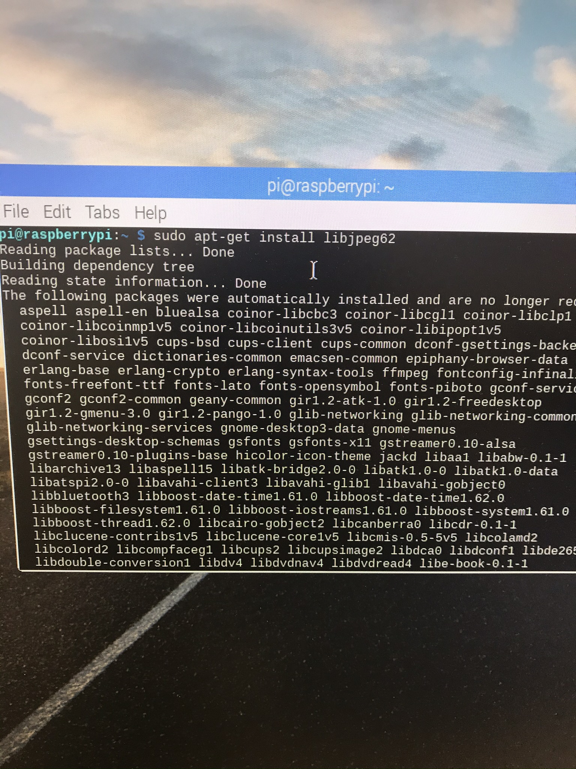

# Step 4: Create a new directory and download the mmal-motion.conf file

Use “mkdr” to make a directory called mmal. Then download and extract the file show below from drop box.

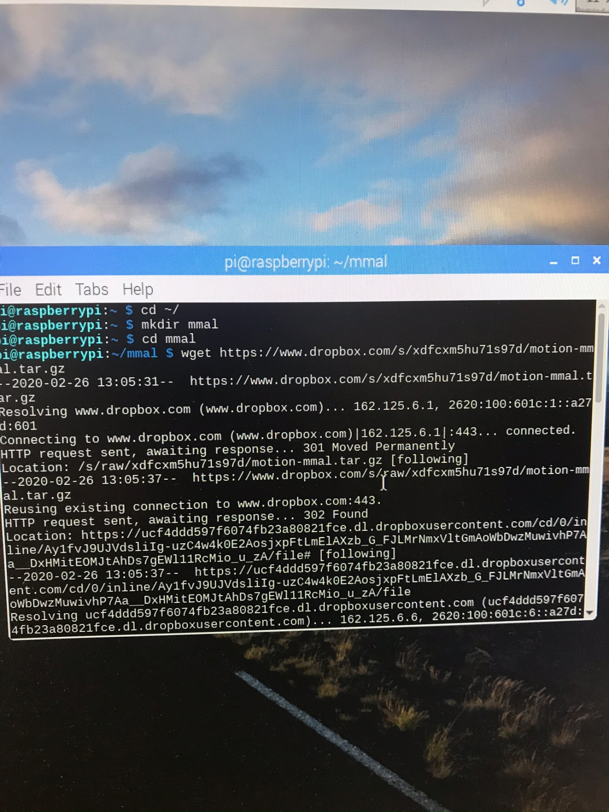 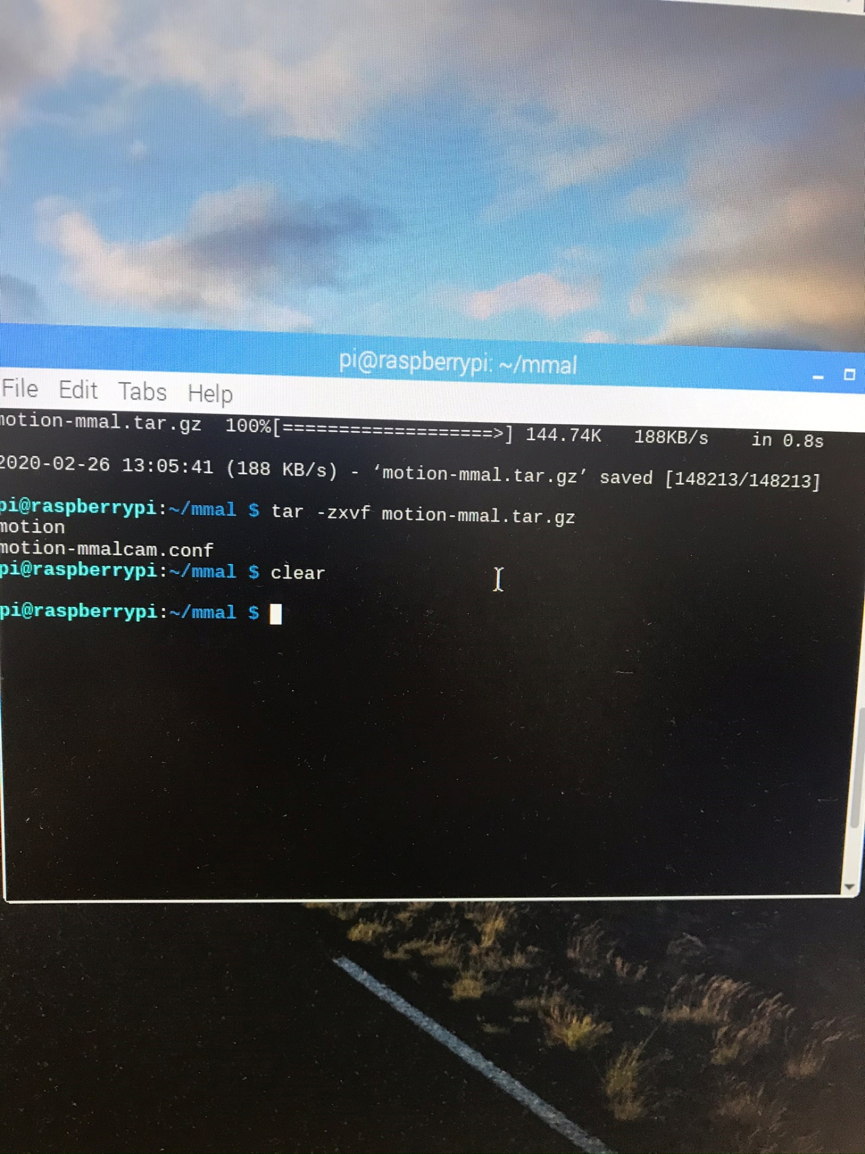

# Step 5: Edit the mmal-motioncam.conf file

You can use either the file directory to navigate to and open this file, or you can use the command “nano” with the filepath in cmd to edit it. Make the following edits:

* Stream_maxrate 100
* Logfile (to the current mmal directory)
* Output_pictures off
* Target_dir (to the current mmal directory)
* Width 640
* Height 480
* Framerate 100

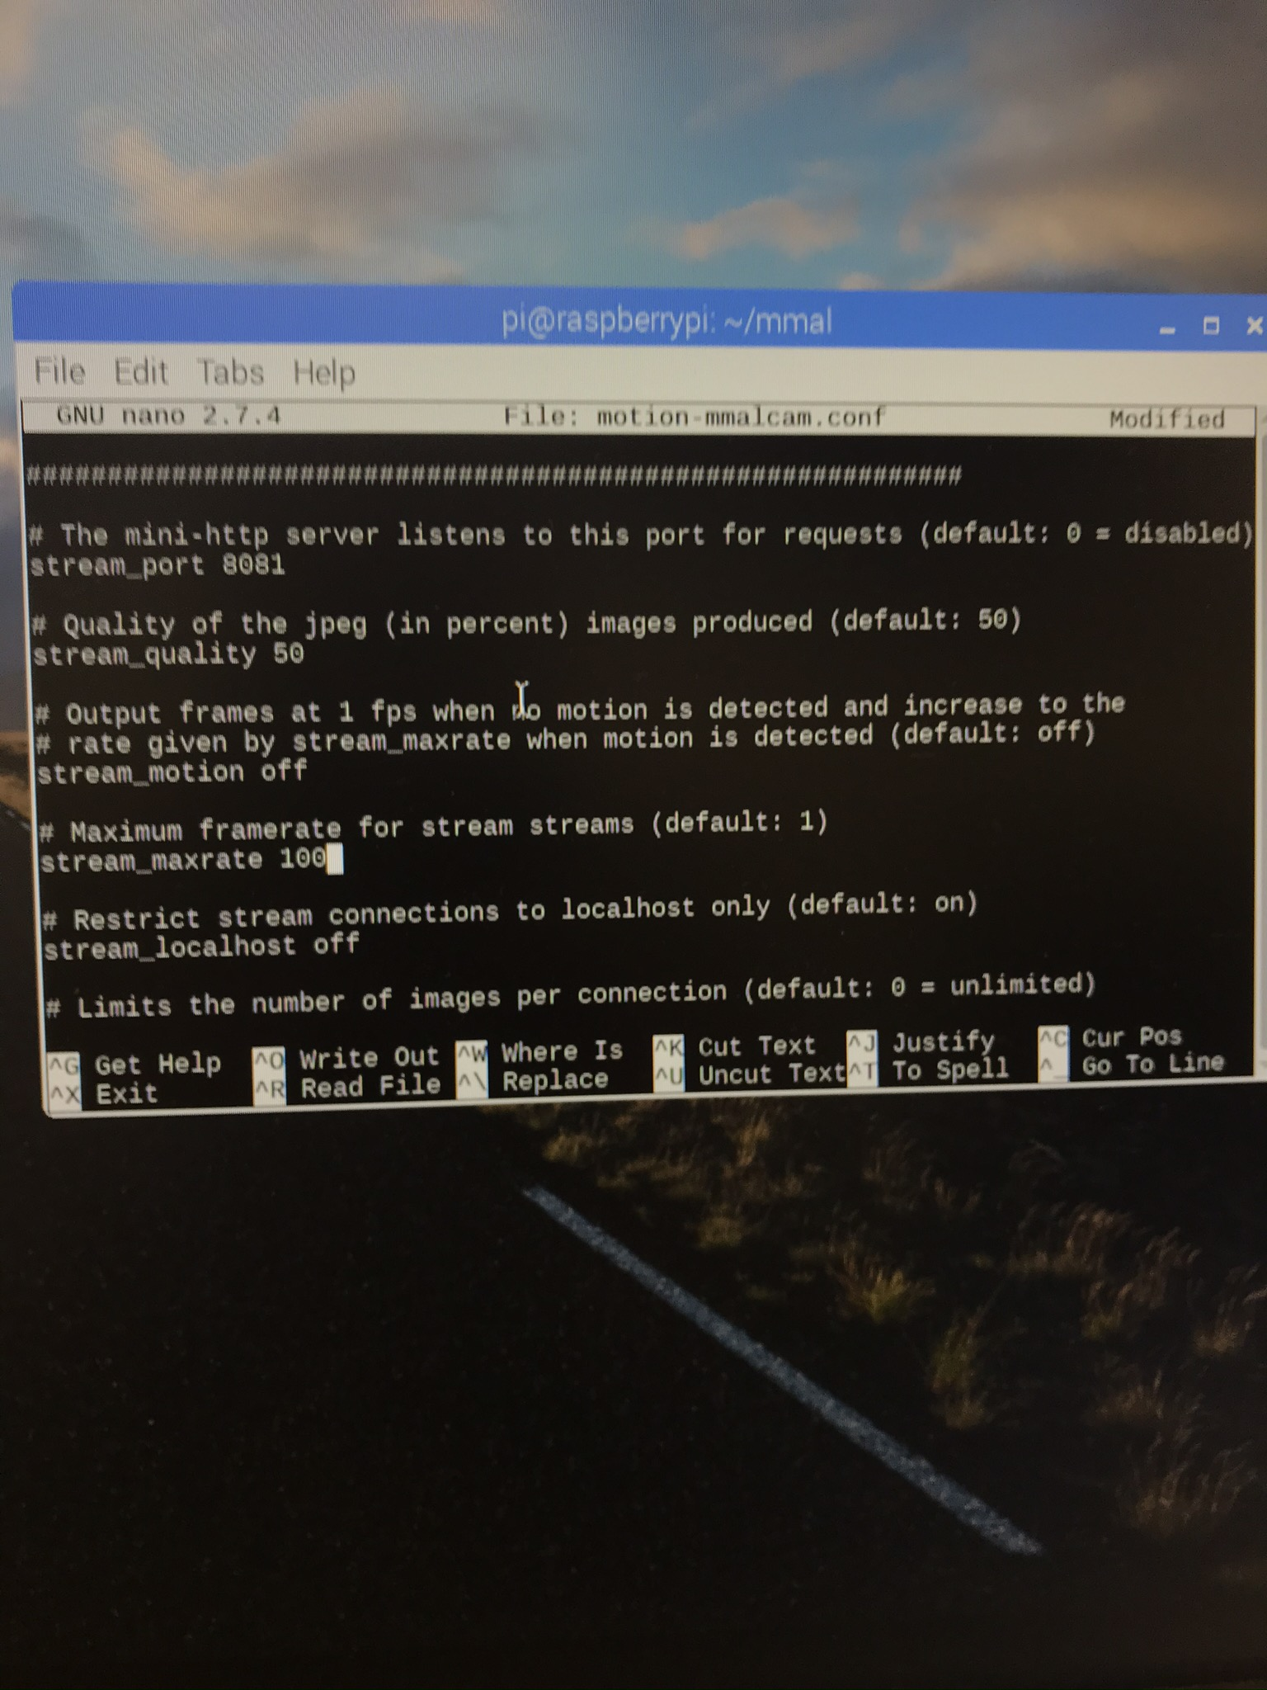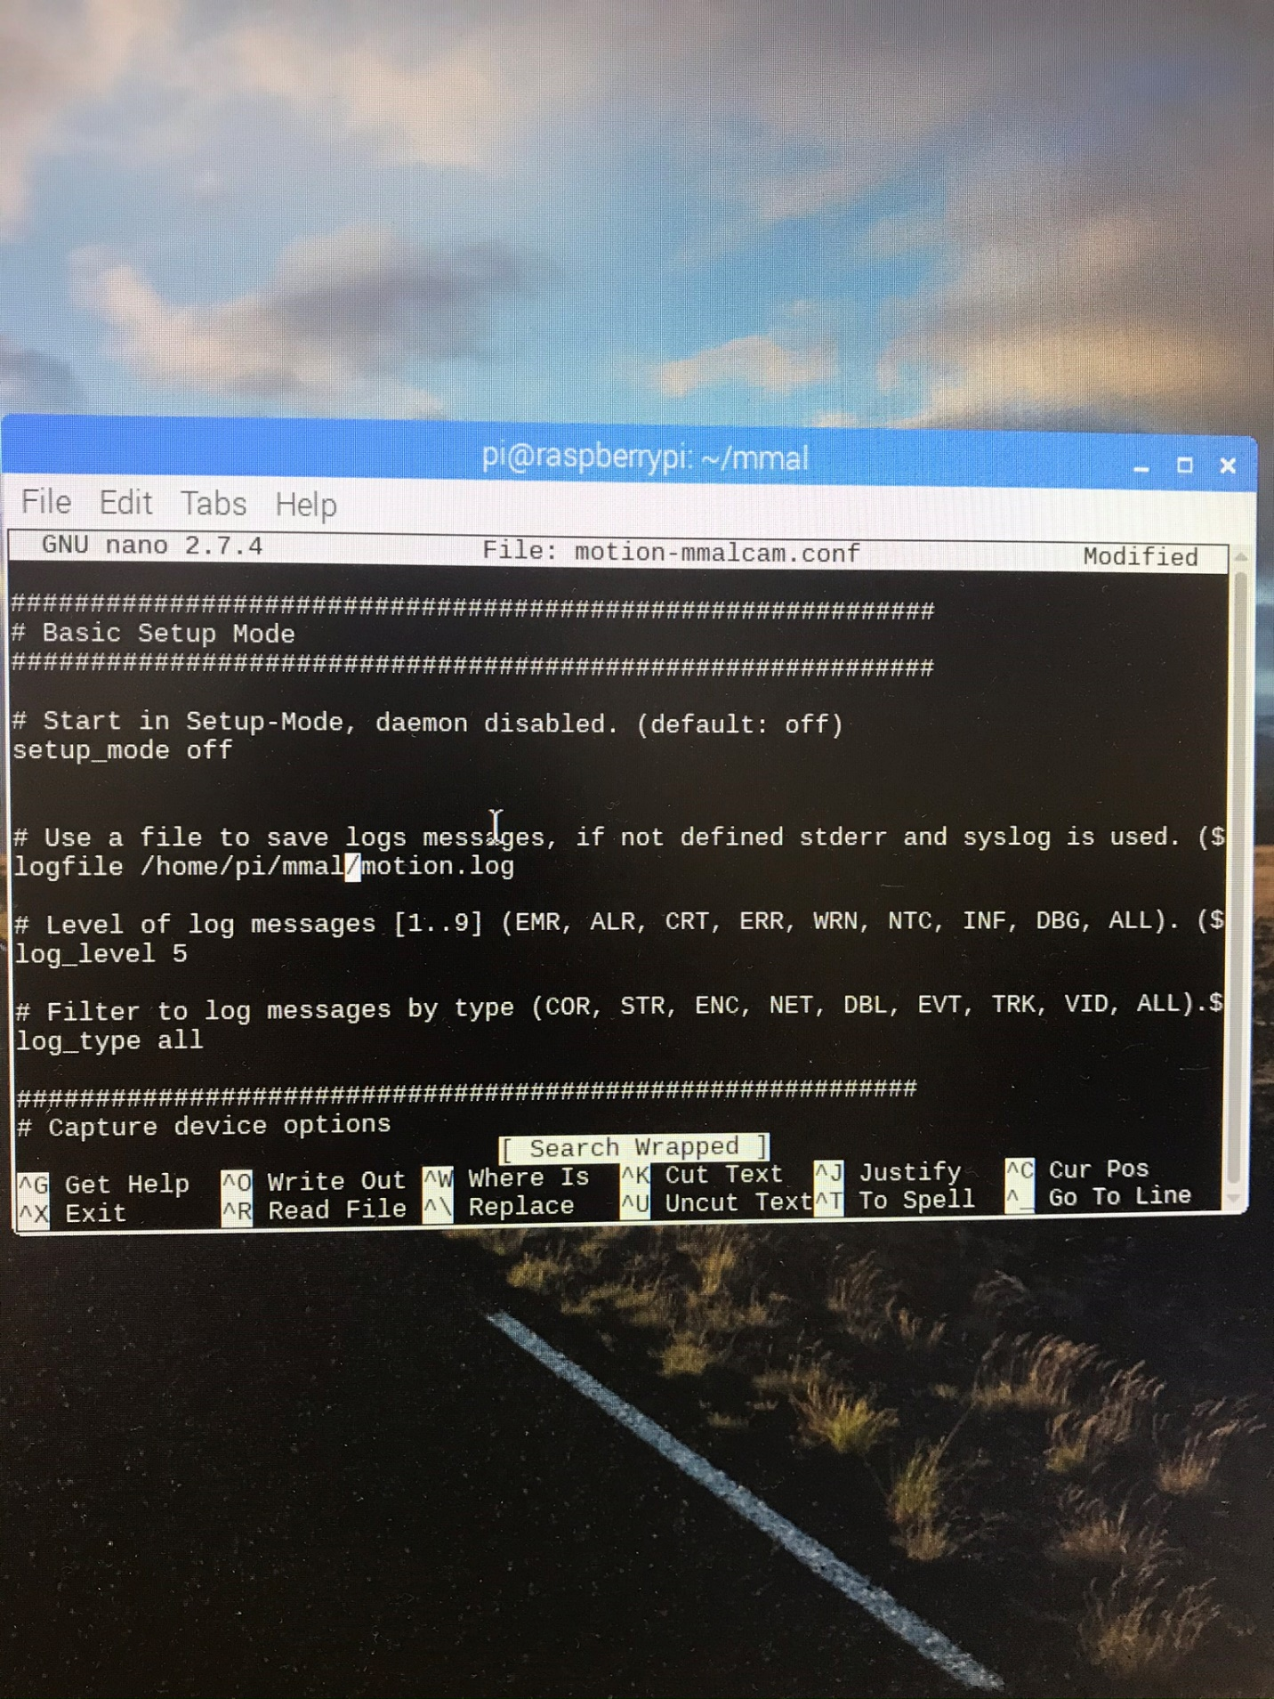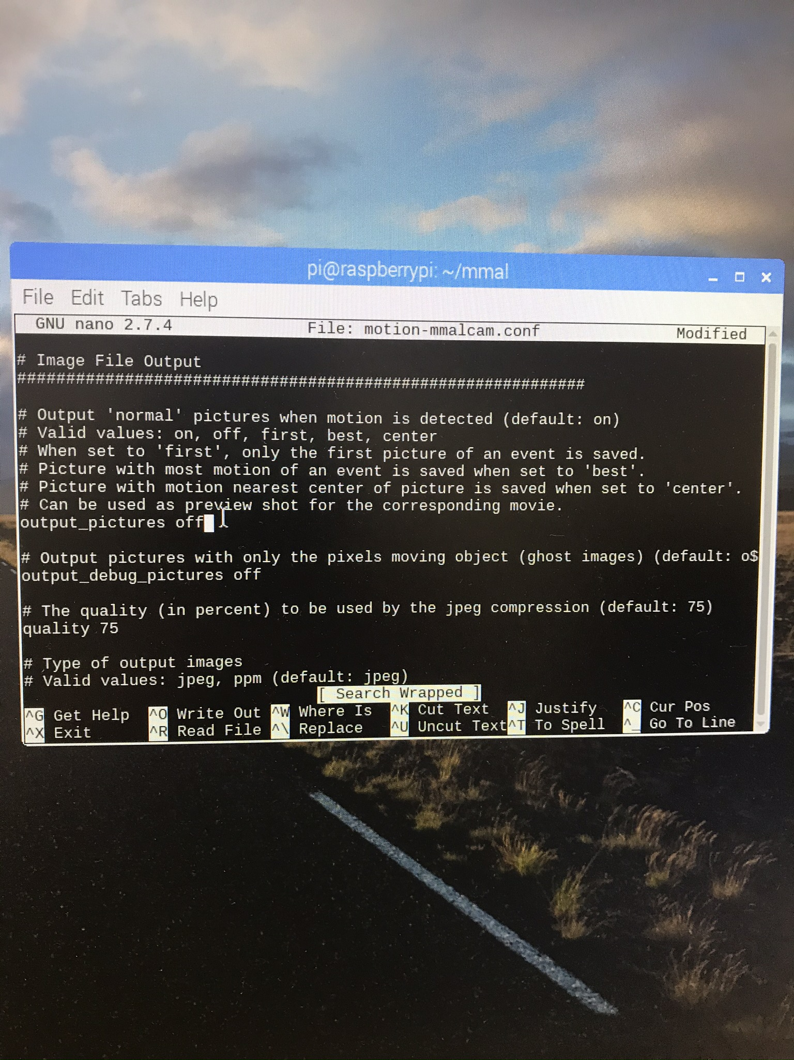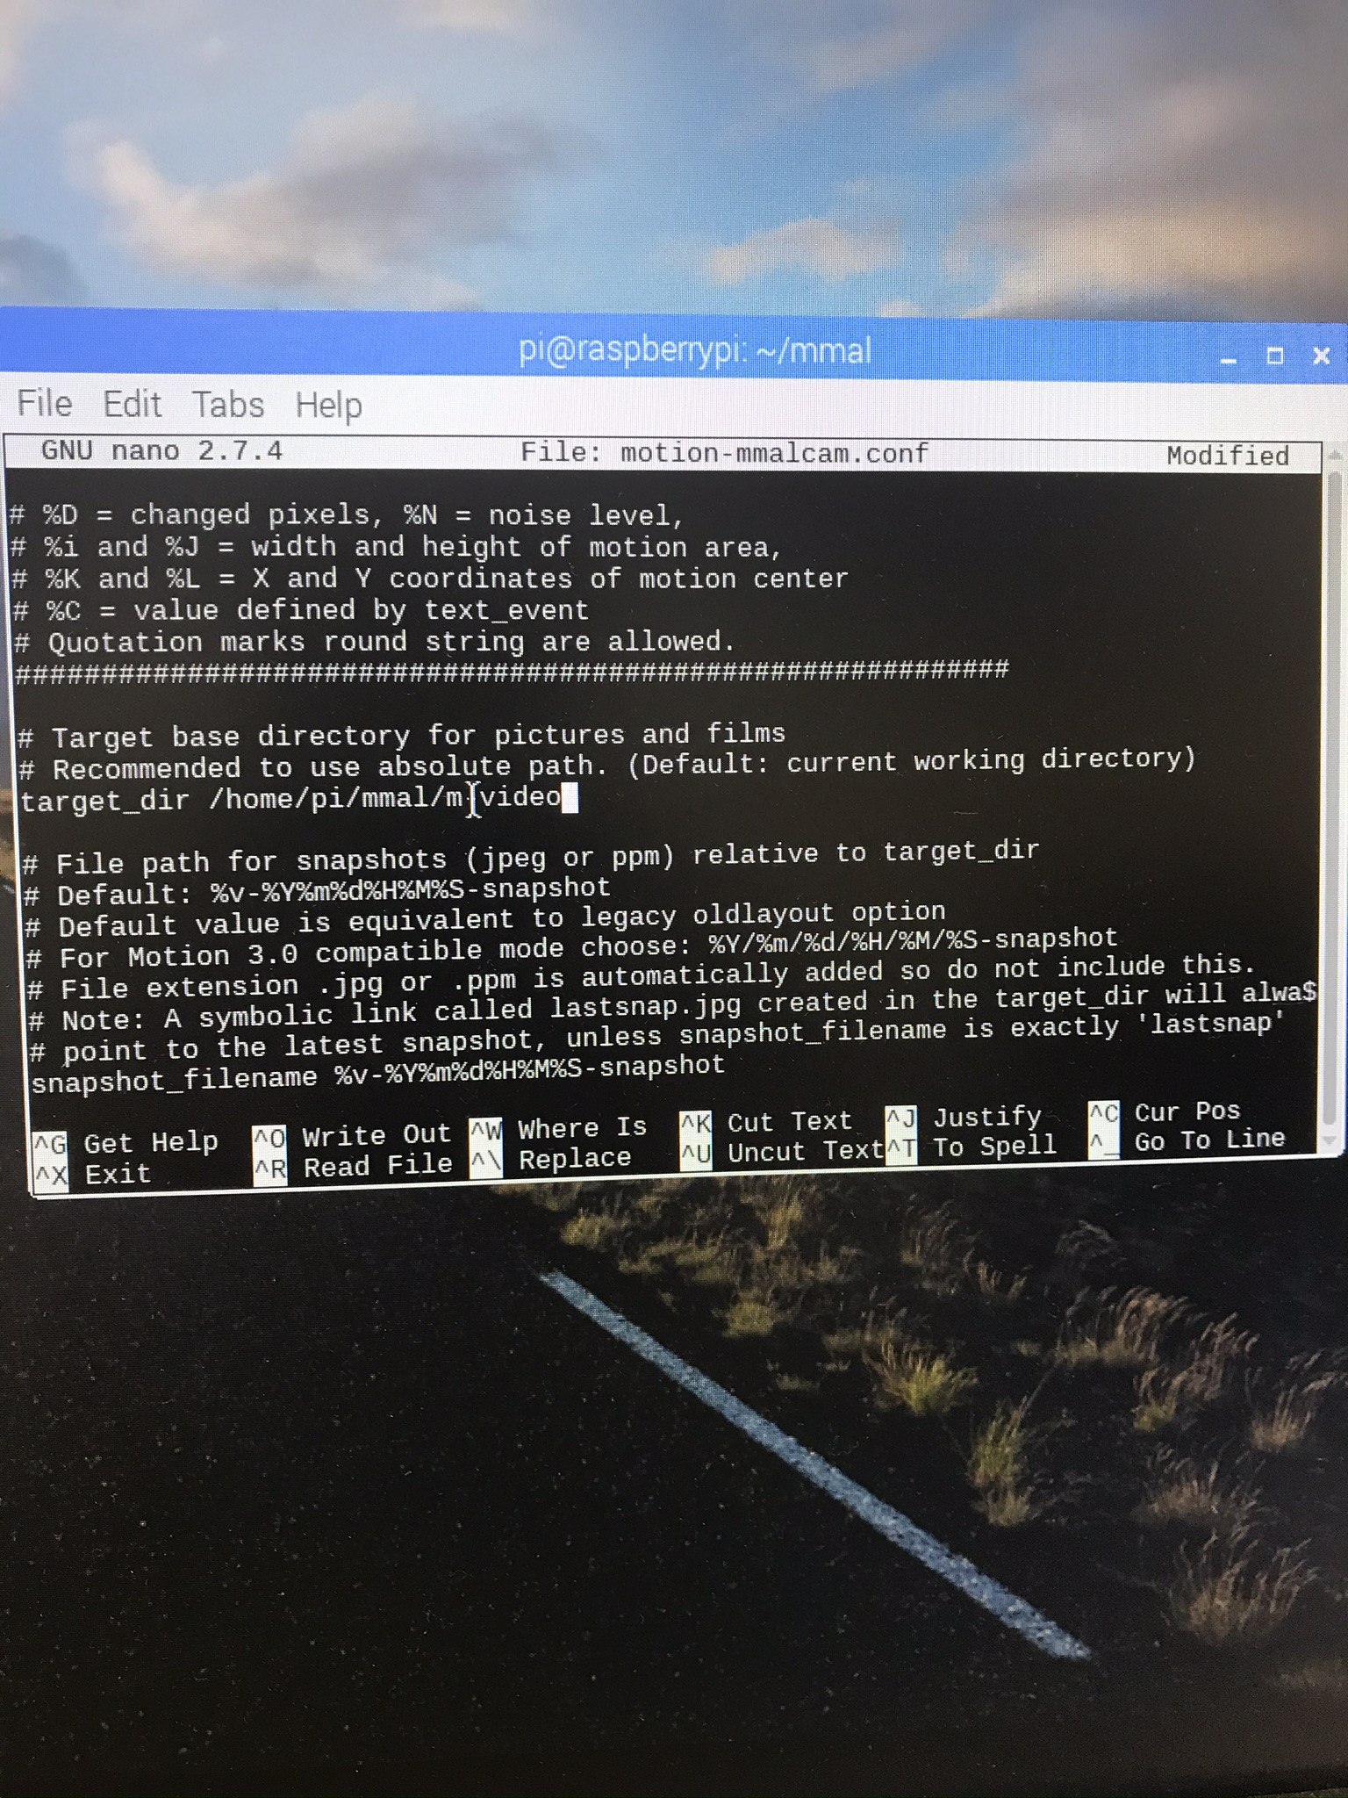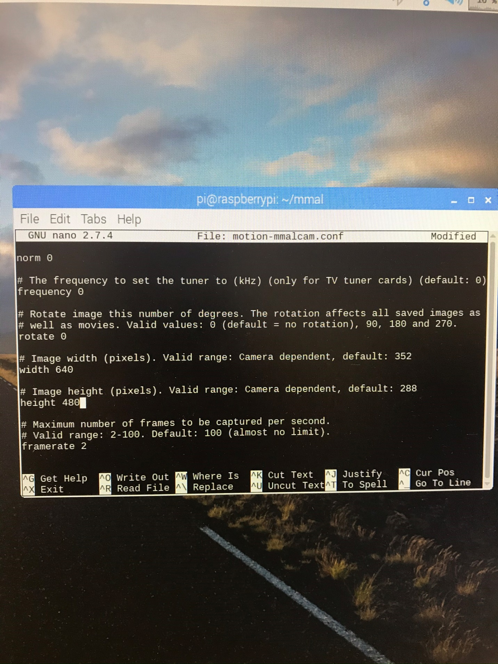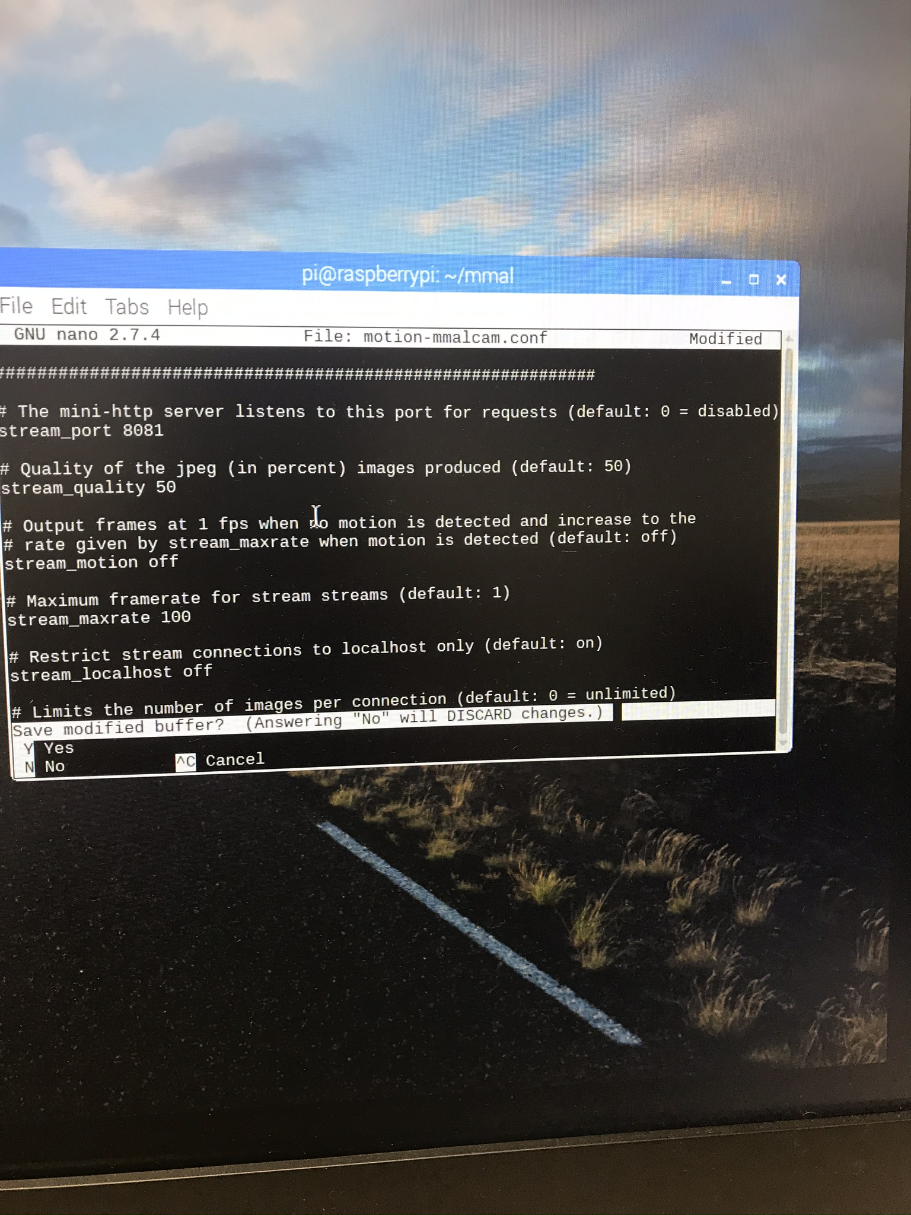

# Step 5: View stream

Open your web browser and type your ip address followed by “:8081” (it is broadcast on port 8081)

